**Mario Remodel**

**-Anurag 19csu044**

**Description**

Mario is an arcade game in which the main protagonist had to run through the level against the time to reach to the Bowser’s (The Main Antagonist) Castle to rescue Princess Peach which bowser abducted her before.

In this Mario has to go through different obstacles and enemies to reach the end.

How his adventure goes?

You will have to find that on your own.

**Mechanics**

You can control your player with the arrow keys and make him jump by hitting the spacebar. Jumping through the obstacles and different enemies is your only goal for now to reach the Bowser’s Castle.

Falling off from the ground will result in Game Over Screen.

Getting hit by the enemies 2 times will result in death as well.

Hitting the enemies on top of their heads will result in demolishing their existence.

And coins collecting is the only side quest that you can keep in mind while thinking about Princess Peach.

**Assets**

1. Mario

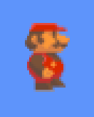

1. Coins



1. Bricks

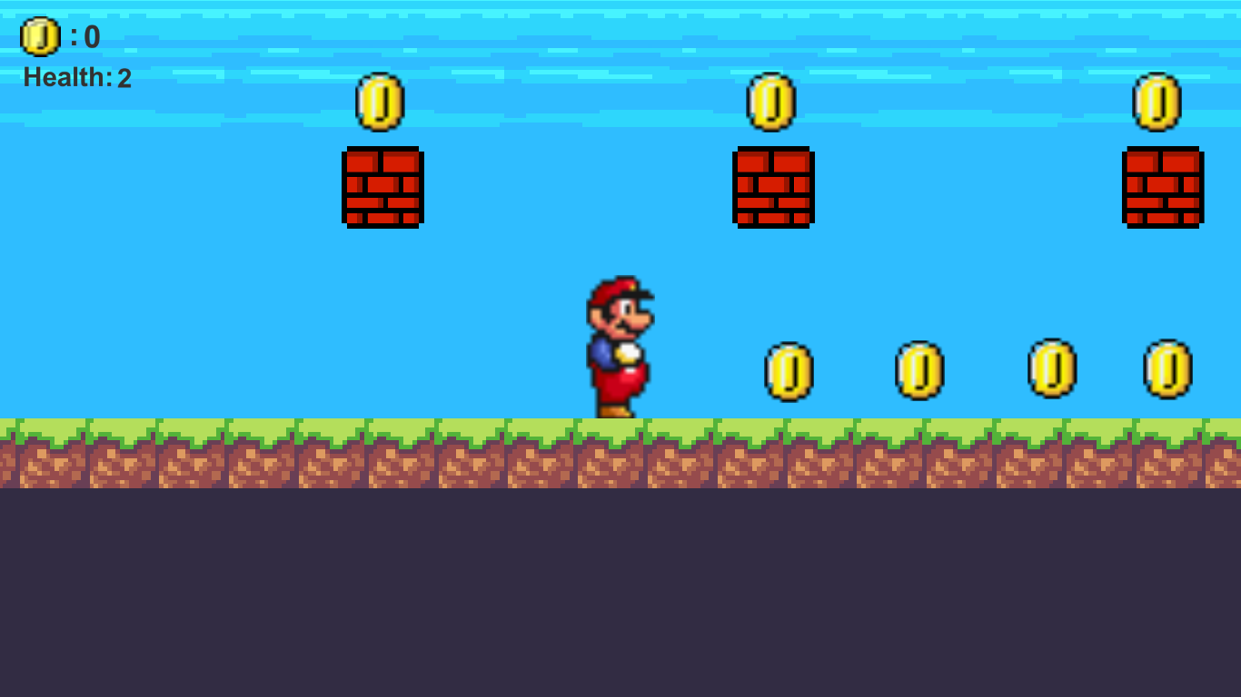

1. Goomba

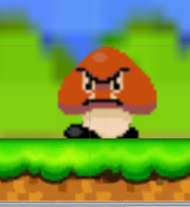

1. Piranha Plant



1. Castle

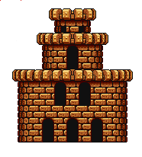

**Background**

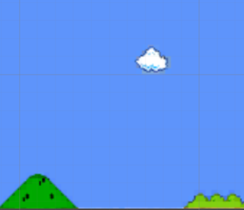

**Screenshots of the Gameplay**

